Link&Learn Instructions : MUST use Internet Explorer or Firefox
- Use the link on our Pennstate Vita website: pennstatevita.weebly.com/volunteer
  - Click download under Taxwise Orientation

- Click on Tax Software Practice Lab. You will be leave IRS and be directed to the site below.
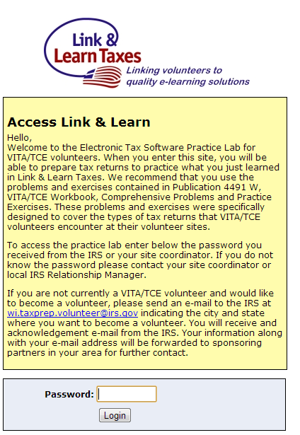
- Enter the password: learntwo
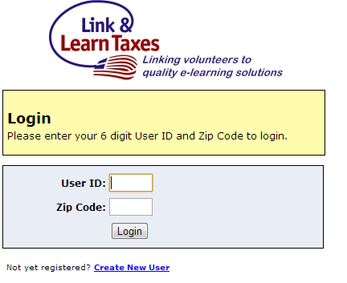
- Click Create New User.
  - Enter your zipcode and email address.
  - A six digit number will be emailed to you
  - DO NOT LOSE THIS NUMBER !!!
- Once you are logged in your Taxwise screen should resemble the image below:
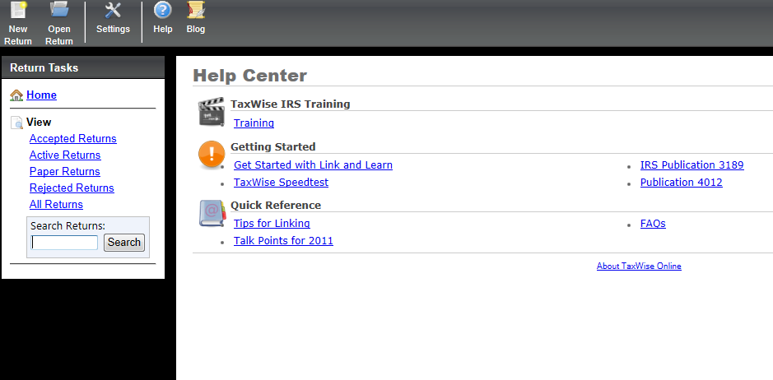
- While practicing preparing returns you will click New Return in the top left.
  - SSN: _ _ _ - _ _ - _ _ _ _
  - SSN: any 3 + your 6 digit ID
  - Remember the 3 digits you used to start the SSN in case you want to go back to the return.
- You may also access the training material

