Self-Training
- Log onto the IRS website: http://apps.irs.gov/app/vita/
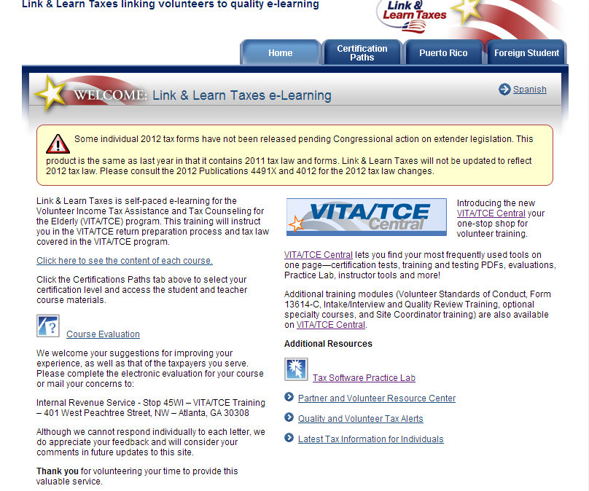
- Choose Certification Paths and go through the basic and intermediate courses.
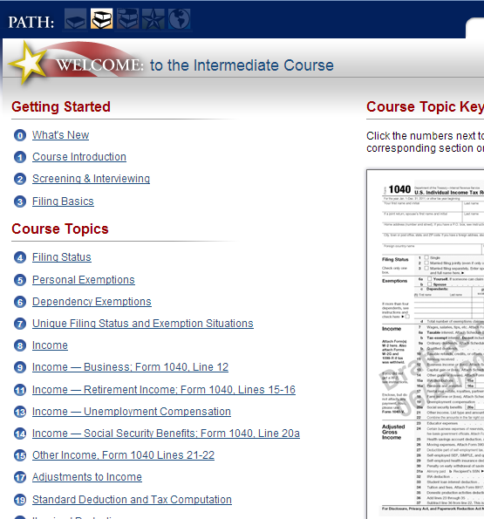
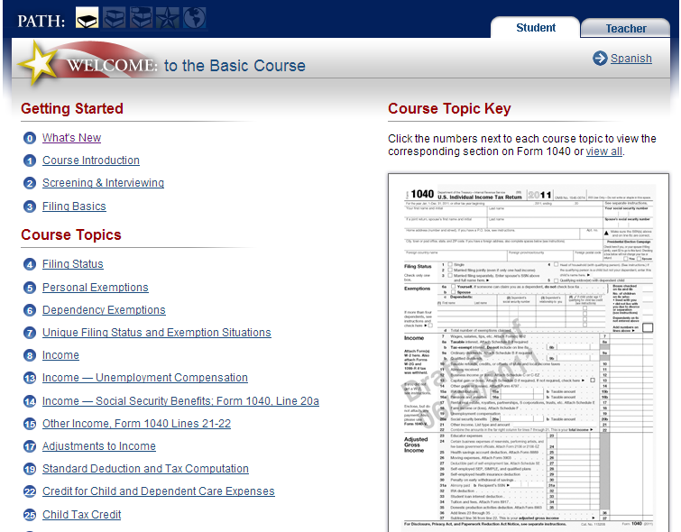
VITA/TCE CENTRAL (Exams)
- Once you are ready to take the exams create your Exam account
- Visit https://www.linklearncertification.com/d/
- Create a new account
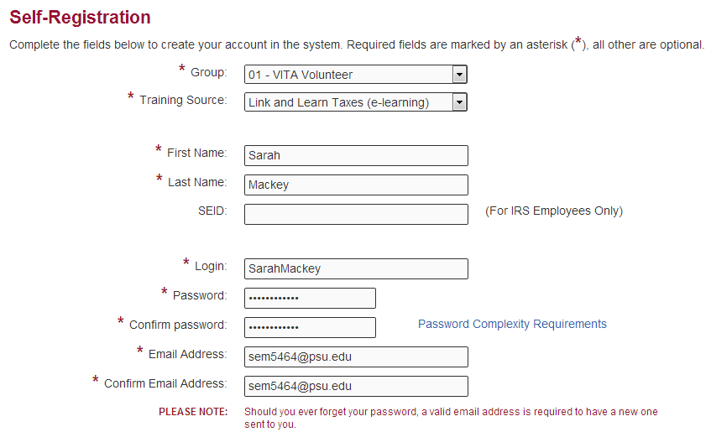
- You must PASS the following exams.
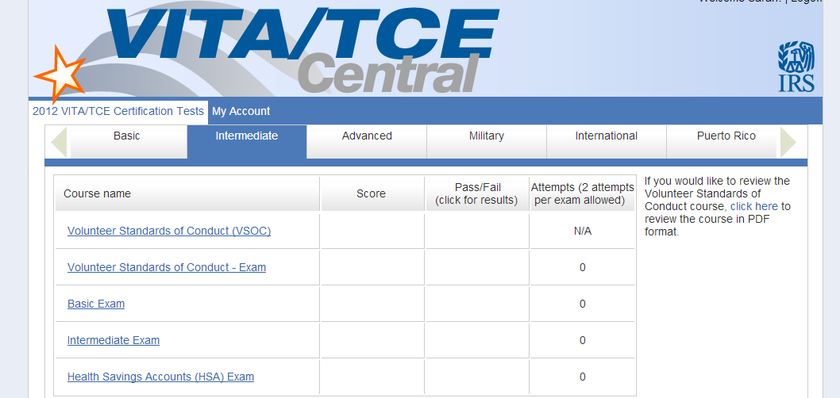
- Print out the summary of your test results.
